## Introduction

### 1.1 Company Profile:

### ...

**• Address:** A/P-Valivade, tal-karveer, Dist-Kolhapur, Maharashtra, India.

**• Since:** 12 Years

**• Working With:**

**COMTRANSE TECHNOLOGY Pvt. Ltd** is a leading software development company proving software consultancy and solution to Educational Institutes, Hotel, Hospital, and Library. As well as they provide a ERP and E-commerce solutions

**COMTRANSE TECHNOLOGY Pvt. Ltd**, a Leading and reputed Software Company in Kolhapur, South Maharashtra. The main reason to set-up our Software Company in Kolhapur, is to provide the best industry level services locally. While doing the Market Survey in year 2010,we have noticed that businesses in the South Maharashtra cities like Sangli, Satara, Kolhapur, and Miraj are lagging just due to not getting a proper technology support. The name '**COMTRANSE**' is fusion of **Computing, Transaction and Services**, representing service commitments to customer for all their computing needs by employing latest technologies. There are many IT companies, who provide various services in IT Field, like Customized Software Development, Web site Designing, Internet Marketing Solutions, but most of them are situated in Metro Cities.

"**Comtranse Technologies**" has a team of knowledgeable and experienced System Analysts and Software Engineers. These members have in depth knowledge of various system platforms and front ends and support customer offering quick service support.

## About Project and Module

This project is an **Joint Director Higher Education, Kolhapur** with Office Automation Systemdone for **Comtranse Technology Pvt. Ltd. Kolhapur**. This system has two users i.e., Admin and the employee of the office. Admin is a person who will manage the system and create new user. Admin creates the users and gives access to the particular employee; this means that each employee can access only those forms which the admin allows him.

The main goal of this system is to adopt the automation in the working of the office. All the work which was carried out till now was recorded on paper. It was such a lengthy and time-consuming process. This project solves the above problem.

The Office Automation System is developed to keep the detail information regarding different users. Different role and role permissions can be defined by admin of the system and for each user different roles are assigned by admin. According to user role permissions the user can get access to the different forms of the system.

The Office Automation System has been developed for maintaining the information of the entire organization and working of the organization and also keeps the records. The computerized system can help the user to effectively manage all the information and data processed throughout a particular work carried out.

Main objective of the system is to keep track of the ongoing work, manage the visitors of the office, storing the data of the visitors in well managed manner. Keeping record of particular file which is submitted to the office. Once a visitor submits his work to the office the real working of the project takes place. All the record related to the visitor, his documents, type of work, also required steps to be followed to complete the task can be easily managed.

This system is divided into different modules which are as follows -

1. HR MODULE.
2. MASTER MODULE.
3. FRONT OFFICE MODULE.
4. WORK FLOW MANAGEMENT MODULE.
5. FILE MANAGEMENT MODULE.

**Working Of System (Modules): -**

1. **HR MODULE:**

HR is the admin of system. He is the head who manages the all users of system. HR do user’s registration and gives Username and password to enter the system. Also HR assign the access of module to the user ,so the access given only those users can handle that module or work. HR manages the overall performance of users.

1. **MASTER MODULE:**

The master module includes all the basic information related to the working of the system. This module gives access of various master forms related to the particular task. Master forms are the core part of the system which gathers all the information which is important in order to carry out the working of the system smoothly. These forms provide the functionality of selecting a particular data related to the work carried out throughout the system. Other users of the system with the help of master forms can select the appropriate data which gives the detailed insights of the work carried out.

1. **FRONT OFFICE MODULE:**

This module is the entry point of the system from where the actual working of the system begins. The FRONT OFFICE MODULE is designed to keep the record of the incoming and outgoing data of the office. It means that with the help of the FRONT OFFICE MODULE the user can store all the information of the visitors of the office, the postal transactions carried out, the call log details of the office, also the complaints which have been register at the office.

In short, FRONT OFFICE MODULE works as the main and primary module where the user can interact with all the data. This data is the important aspect of the system as it gives all the meaningful information of the work being carried out at the office.

1. **WORK FLOW MANAGEMENT MODULE:**

WORKFLOW MANAGEMENT is a comprehensive module designed to streamline task assignment and monitoring within a department. This system aims to enhance efficiency, collaboration, and transparency among employees. It offers a user-friendly interface to manage tasks seamlessly. In Task Assignment, employees have the ability to assign tasks to their colleagues within the department. Once a task is assigned, employees can track the progress of their tasks. The system categorizes tasks

into three statuses: pending, running, and complete which helps in instantly identifying the status of each task. Employees can access comprehensive task details for each assignment.

The system also provides a Task Reporting feature, enabling employees and managers to generate reports about the status of tasks within the department.

Overall, this Module is an indispensable tool for enhancing task assignment and monitoring in a department. It promotes better collaboration, efficiency, and accountability by allowing employees to assign, monitor, and report on tasks seamlessly.

1. **FILE MANAGEMENT MODULE:**

FILE MANAGEMENT serves as the primary function within the Office Automation System, overseeing the official process of issuing certificates to Applicants.This comprehensive process involves four distinct steps. Initially, the details provided in the application are scrutinized, and the necessary documents for the certificate are dispatched. Following this, the application advances to the subsequent desk for the uploading of required documents. Upon reaching next desk, a meticulous examination is conducted to ensure the correctness and validity of both the original and uploaded documents. At last desk, successful verification is achieved, and a responsive employee can then issue the certificate to the applicant.Verified certificates find their place in the warehouse, each assigned a file number and organized on the rack. This systematic storage approach facilitates easy retrieval for purposes of reissuing or reprinting certificates.

In essence, this module streamlines the creation, issuance, and storage of certificates, thereby significantly reducing the volume of paperwork, time expenditure, and associated costs.

.

## Existing System

1. The existing system of the office is manual system with limitation like accuracy, expense, low speed and efficiency and unformatted outputs.
2. In the existing system, all data processing is done manually. There is a lot of issues such as retrieval and storage of the information and keeping track of them becomes a tedious task.
3. The office uses record books and the traditional methods to store and process the data. Doing this needs a huge employee engagement and a lot of time.
4. It becomes difficult for the employees to carry out all the tasks and manage the efficient working of the office.
5. There is no computer system for handling services & Payment. All calculations are performed manually which may not be accurate always. Maintaining the record is really a tedious task.
   * 1. **Limitations of Existing system**
6. The drawback of existing system is lack of data integrity and accuracy.
7. Old system requires more man power and employee engagement to carry out the working.
8. Using old system, it is a difficult to handle task such as work assignment, human resource assessment and visitors log information management.
9. It is difficult for the employees to communicate between them and complete the task immediately.
10. As all the working is based on manual working it requires lot of time and energy to complete a particular task.
11. The manual system gives us very less security for saving data; some data may be lost due to mismanagement.

## Need and Scope of Computer System

1. To maintain the information about the task carried out.
2. To manage all the information and working of the office daily tasks.
3. Help employees to check the status of the task carried out.
4. To maintain the data integrity.
5. For effective working of the resources available.
6. Automation will reduce the overall time required to complete a task.
7. To increase the productivity of the employees.

## Organization Profile

Directorate of Higher Education is the nodal agency sponsored and activated by the Ministry of Higher Education, Government of Maharashtra. The Directorate is headed by the Director of Higher Education and office is located at Central Building, Pune. There are 10 Regional Joint Directors. The office of the **Regional Joint Director, Higher Education, Kolhapur** is the controlling office for three districts namely Kolhapur, Sangli and Satara along with Shivaji University, Kolhapur. In 1992, Government of Maharashtra bifurcated “Higher & Technical Education Department” from “School Education Department”. The main purpose was to improve the facilities & raise the standards of Higher Education in Arts, Science, Commerce and education streams at Graduation & Post Graduation levels.

Maharashtra University Act 1994 has empowered all the Universities equally, and has enabled them to effectively carry out the responsibilities & more equitable distribution of facilities for higher education to bring about excellence in higher education. The State Government has to play an important role in this as per the clause 8 of this Act.

The office of the Joint Director monitors all administrative and financial aspects of teaching & non-teaching staff of Shivaji University and 133 grantin- aid colleges in its regional territory.

In addition, this office is controlling following Government organizations / establishments: -

1. Govt. Rajaram College, Kolhapur.
2. Shri Maharani Tarabai Govt College of Education, Kolhapur.
3. Pre IAS-Training Centre, Kolhapur.
4. Govt. EBC Gents Hostel, Kolhapur.
5. Office of the Accts Officer, Higher Education Grants, Kolhapur.
6. Govt. EBC Gents Hostel, Budhgaon, Dist. Sangli.

The main purpose of creation of this office is to provide a bridge among the Higher Education Department and Director of Higher Education along with Shivaji University, grant in aid colleges and above six Govt. establishments in Kolhapur region.

**The main activities of Joint Director, Higher Education, Kolhapur are**

* + Implementation of Education Policies enacted by Department of Higher Education, Government of Maharashtra.
  + To control & co-ordinate Government colleges & Institutions in its region.
  + For grant-in-aid Colleges: Staff Sanction, Staff Recruitment and Fund Allocation, Salary Disbursement.
  + To recommend new colleges.
  + To recommend all pensionary benefits to Teaching as well as Non-Teaching Staff working in 133 non-govt. aided Colleges and Shivaji University, Kolhapur.
  + Teaching / Non-Teaching staff promotions and pay fixations.
  + Assessment of distributed grants for grant in aid work.
  + To monitor working of EBC Hostels.

## Objective

1. To maintain all the information of the task carried out.
2. To automate the overall working of the office which will reduce the waiting time of the visitor.
3. To help employees to establish communication between them within less time.
4. It becomes easy for the employees to assign each other tasks and quickly complete the assigned task.
5. To keep record of the overall visitors of the office, their basic details and information which will further help employees to carry out their task.
6. To store previous data of the application which will ensure that once submitted paper or document will be available throughout the system.
   * 1. **Advantages of proposed system**
7. Computerized system has large storage capacity- That is we can store large amount of data at a time.
8. Accuracy & Efficiency- Computers are very accurate and no wrong data entry is possible because of validation.
9. Required less man power to keeping record and maintain it.
10. The system is user friendly and less time consuming.
    1. **Software Requirements**

We should try to understand what sort of requirements may arise in the requirement elicitation phase and what kinds of requirements are expected from the software system.

Broadly software requirements should be categorized in two categories:

**Functional Requirements**

Requirements, which are related to functional aspect of software fall into this category.

They define functions and functionality within and from the software system. Examples -

* + - Search option given to user to search from various invoices.
    - User should be able to mail any report to management.
    - Users can be divided into groups and groups can be given separate rights.
    - Should comply business rules and administrative functions.
    - Software is developed keeping downward compatibility intact.

**Non-Functional Requirements**

Requirements, which are not related to functional aspect of software, fall into this category. They are implicit or expected characteristics of software, which users make assumption of Non-functional requirements include -

* + - Security
    - Logging
    - Storage
    - Configuration
    - Performance
    - Cost
    - Interoperability
    - Flexibility
    - Disaster recovery

**CodeIgniter**

CodeIgniter is a powerful PHP framework with a very small footprint, built for developers who need a simple and elegant toolkit to create full-featured web applications. CodeIgniter was created by EllisLab, and is now a project of the British Columbia Institute of Technology.

CodeIgniter is an application development framework, which can be used to develop websites, using PHP. It is an Open-Source framework. It has a very rich set of functionalities, which will increase the speed of website development work.

If you know PHP well, then CodeIgniter will make your task easier. It has a very rich set of libraries and helpers. By using CodeIgniter, you will save a lot of time, if you are developing a website from scratch. Not only that, a website built in CodeIgniter is secure too, as it has the ability to prevent various attacks that take place through websites.

**CodeIgniter Features**

Some of the important features of CodeIgniter are listed below –

1. Model-View-Controller Based System
2. Extremely Light Weight
3. Full Featured database classes with support for several platforms.
4. Query Builder Database Support
5. Form and Data Validation
6. Security and XSS Filtering
7. Session Management
8. File Uploading Class
9. Data Encryption
10. Application Profiling

**PHP**

PHP is a general-purpose scripting language geared toward web development.

It was originally created by Danish-Canadian programmer Rasmus Lerdorf in 1993 and released in 1995.

* + - PHP is a recursive acronym for "PHP: Hypertext Pre-processor".
    - PHP is a server-side scripting language that is embedded in HTML. It is
    - used to manage dynamic content, databases, session tracking, even build entire ecommerce sites.
    - It is integrated with several popular databases, including MySQL, Oracle, Sybase, Informix, and Microsoft SQL Server.
    - PHP is pleasingly zippy in its execution, especially when compiled as an
    - Apache module on the Unix side. The MySQL server, once started, executes even very complex queries with huge result sets in record- setting time.
    - PHP4 added support for Java and distributed object architectures (COM and CORBA), making n-tier development a possibility for the first time.

**Characteristics of PHP**

Five important characteristics make PHP's practical nature possible-

* + - Simplicity.
    - Efficiency.
    - Security.
    - Flexibility.
    - Familiarity.

**CSS**

Cascading Style Sheet (CSS) is used to set the style in web pages that contain

HTML elements. It sets the background colour, font-size, font-family, colour, etc. property of elements on a web page.

### There are three types of CSS which are given below:

1. Inline CSS
2. Internal or Embedded CSS
3. External CSS

### Inline CSS

Inline CSS contains the CSS property in the body section attached with element is known as inline CSS. This kind of style is specified within an HTML tag using the style attribute.

### Internal CSS

This can be used when a single HTML document must be styled uniquely. The CSS rule set should be within the HTML file in the head section i.e., the CSS is embedded within the HTML file.

### External CSS

External CSS contains separate CSS file which contains only style property with the help of tag attributes (For example class, id, heading, … etc). CSS property written in a separate file with .CSS extension and should be linked to the HTML document using link tag. This means that for each element, style can be set only once and that will be applied across web pages.

**JavaScript**

* Loosely type descripting language.
* Java Script function is called when an event occurs in a page.
* Glue for the whole AJAX operation.

**Back End: MySQL**

### Introduction with MySQL

MySQL is a fast, easy-to-use RDBMS being used for many small and big businesses.

MySQL is developed, marketed, and supported by MySQL AB, which is a

Swedish company. MySQL is becoming so popular because of many good reasons –

* + MySQL is released under an open-source license. So, you have nothing to pay to use it.
  + MySQL is a very powerful program. I than sub set of the functionality of the most expensive and powerful data base packages.
  + MySQL uses a standard form of the well-known SQL data language.
  + MySQL works on many operating systems and with many languages including PHP, PERL, C, C++, JAVA, etc.
  + MySQL works very quickly and works well even with large datasets.
  + MySQL is very friendly to PHP, the most appreciated language for web development.
  + MySQL supports large databases, up to 50 million rows or more in a table. The default file size limit for a table is 4GB, but you can increase this (if your operating system can handle it) to the orifical limit of 8 million tera bytes (TB).

## Data Flow Diagram

* + 1. **Context level Data Flow Diagram**

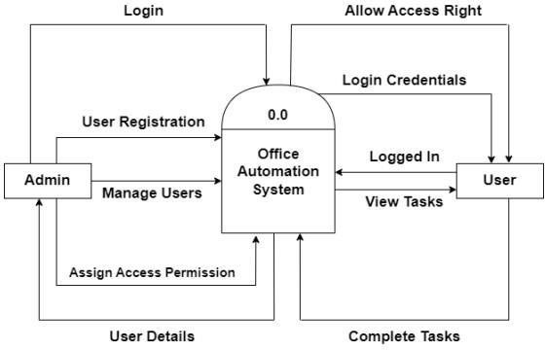

* + 1. **First level DFD**

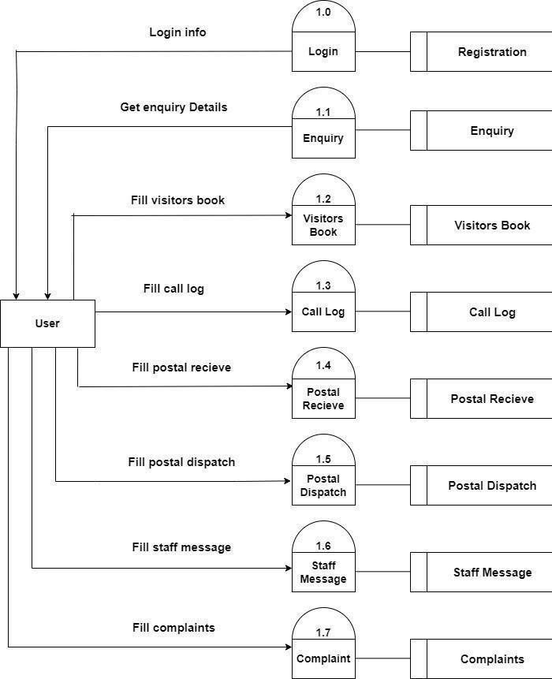

## 3.2. E-R Diagram

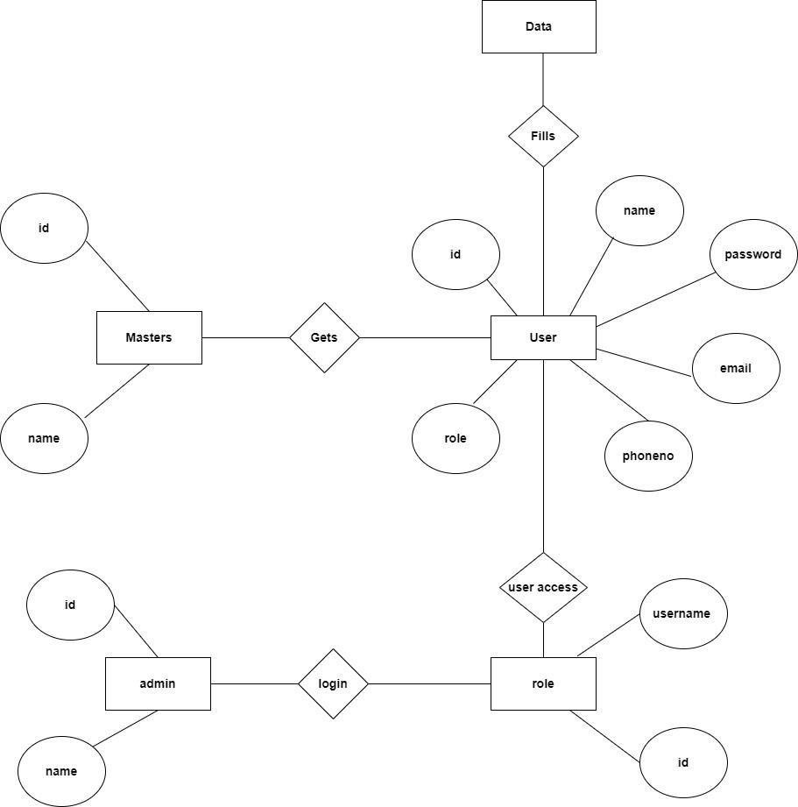

* 1. **Unified Modelling Language Diagram**
     1. **Use Case Diagram**

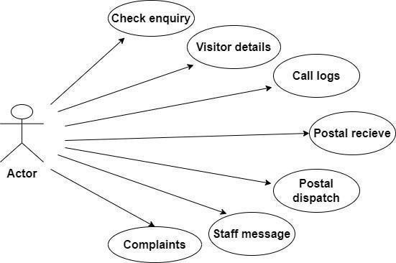

## Database Design

**Enquiry Table-: -**

|  |  |  |  |
| --- | --- | --- | --- |
| **Name** | **Data Type** | **Size** | **Constrain** |
| EnqId | bigint | 15 | Primary key |
| EnqName | varchar | 25 |  |
| EnqTime | time |  |  |
| Date | date |  |  |
| RefType | varchar | 25 |  |
| RefName | varchar | 25 |  |
| RefNo | int | 15 |  |
| EnqRsn | varchar | 25 |  |

**Visitors Book Table-**

|  |  |  |  |
| --- | --- | --- | --- |
| **Name** | **Data Type** | **Size** | **Constrain** |
| VId | bigint | 15 | Primary key |
| purpose | varchar | 25 |  |
| Nm | varchar | 25 |  |
| Mobno | int | 15 |  |
| Date | date |  |  |
| Noper | int | 15 |  |
| InTime | time |  |  |
| OutTime | time |  |  |
| Address | varchar | 25 |  |

**Call Log Table-**

|  |  |  |  |
| --- | --- | --- | --- |
| **Name** | **Data Type** | **Size** | **Constrain** |
| CallId | bigint | 15 | Primary key |
| Calltype | varchar | 25 |  |
| EmployeeName | varchar | 25 |  |
| CallPersonName | varchar | 25 |  |
| CallDate | date |  |  |
| CallReason | varchar | 25 |  |
| CallTime | time |  |  |
| NextFollowDate | date |  |  |
| Description | varchar | 30 |  |
| Feedback | varchar | 30 |  |

**Postal Receive Table-**

|  |  |  |  |
| --- | --- | --- | --- |
| **Name** | **Data Type** | **Size** | **Constrain** |
| RId | bigint | 15 | Primary key |
| InNo | int | 15 |  |
| InDate | date |  |  |
| Name | varchar | 25 |  |
| Place | varchar | 25 |  |
| Address | varchar | 25 |  |
| InNoRef | int | 15 |  |
| InDateRef | date |  |  |
| Sub | varchar | 25 |  |
| Remark | varchar | 20 |  |
| Charge | int | 15 |  |

* + 1. **Postal Dispatch Table-**

|  |  |  |  |
| --- | --- | --- | --- |
| **Name** | **Data Type** | **Size** | **Constrain** |
| DispId | bigint | 15 | Primary key |
| OutNo | int | 15 |  |
| OutLetterNo | int | 15 |  |
| OutDate | date |  |  |
| Name | varchar | 25 |  |
| Place | varchar | 25 |  |
| Address | varchar | 25 |  |
| InNoRef | int | 15 |  |
| InDateRef | date |  |  |
| Subject | varchar | 25 |  |
| Remark | varchar | 20 |  |
| Charge | int | 15 |  |

**Staff Message Table-**

|  |  |  |  |
| --- | --- | --- | --- |
| **Name** | **Data Type** | **Size** | **Constrain** |
| StaffMsgId | bigint | 15 | Primary key |
| BranchName | varchar | 25 |  |
| EmpName | varchar | 25 |  |
| Time | time |  |  |
| Date | date |  |  |
| Message | varchar | 30 |  |
| MessageType | varchar | 20 |  |
| Source | varchar | 20 |  |

**Complaint Table**

|  |  |  |  |
| --- | --- | --- | --- |
| **Name** | **Data Type** | **Size** | **Constrain** |
| ComplaintId | bigint | 15 | Primary key |
| ComplaintName | varchar | 25 |  |
| MobileNo | bigint | 15 |  |
| Date | date |  |  |
| Description | varchar | 30 |  |

* 1. **Input Design**
     1. **Login**

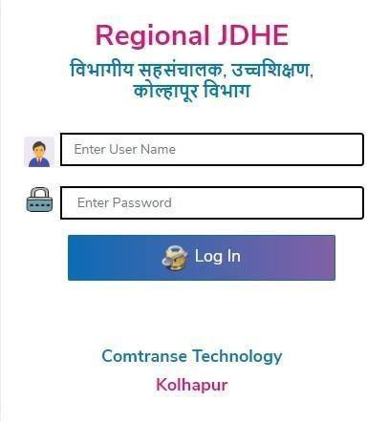

* + 1. **Dashboard**

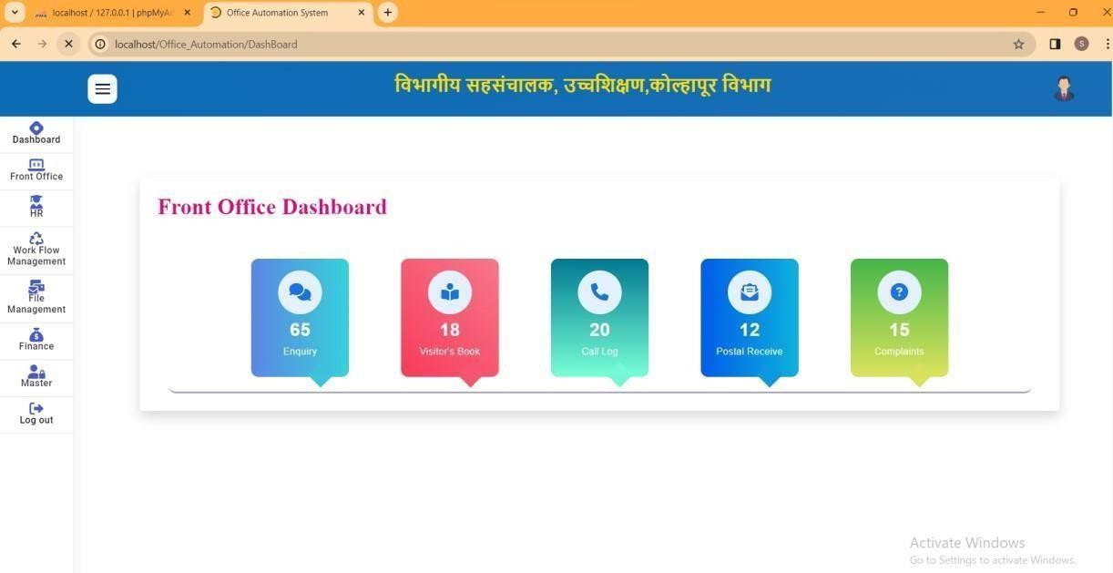

* + 1. **Enquiry Form**

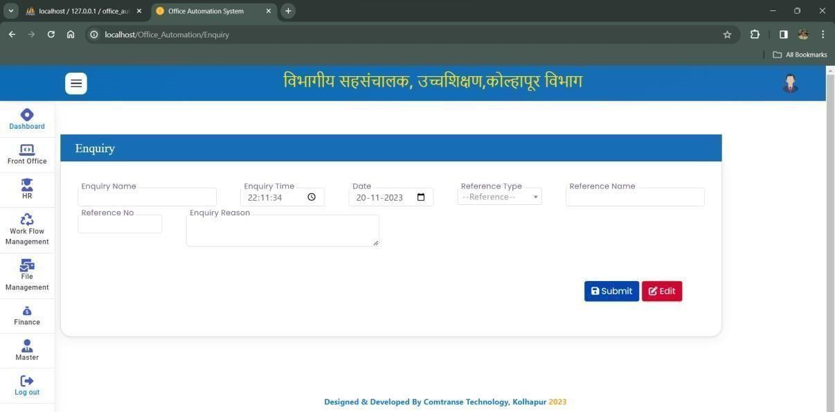

* + 1. **Visitors Book Form**

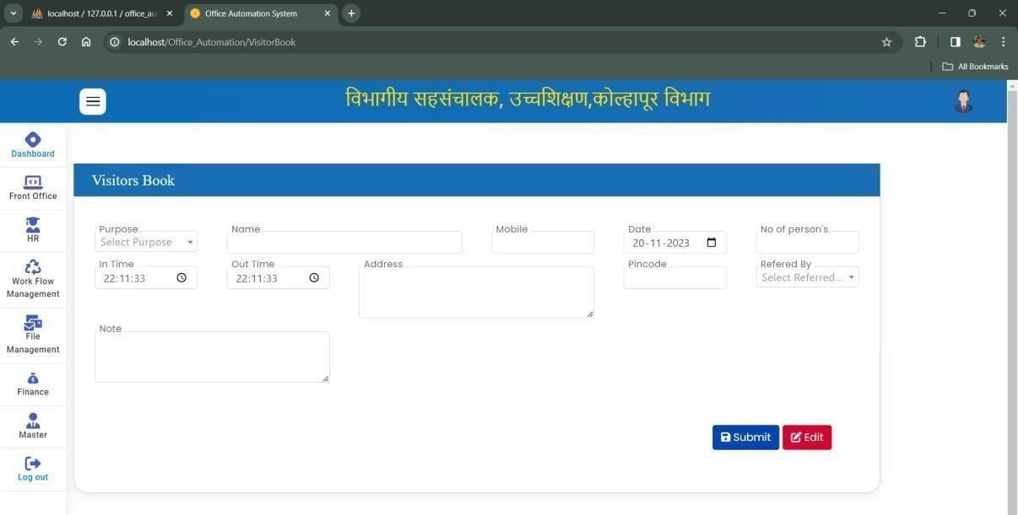

* + 1. **Call log Form**

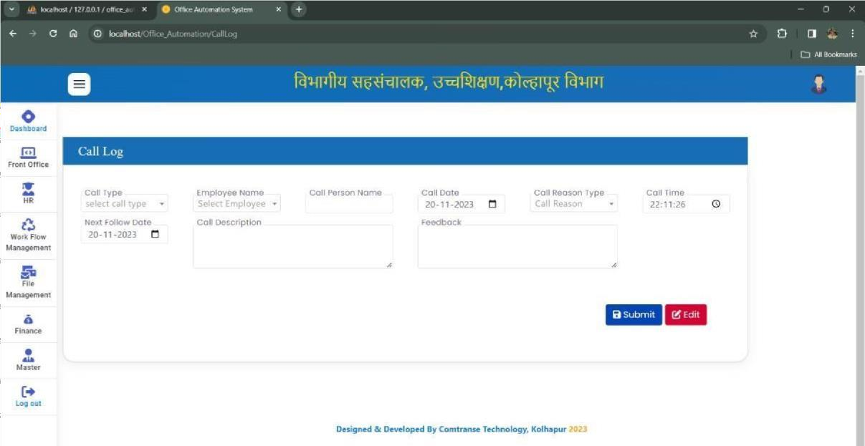

* + 1. **Postal receive Form**

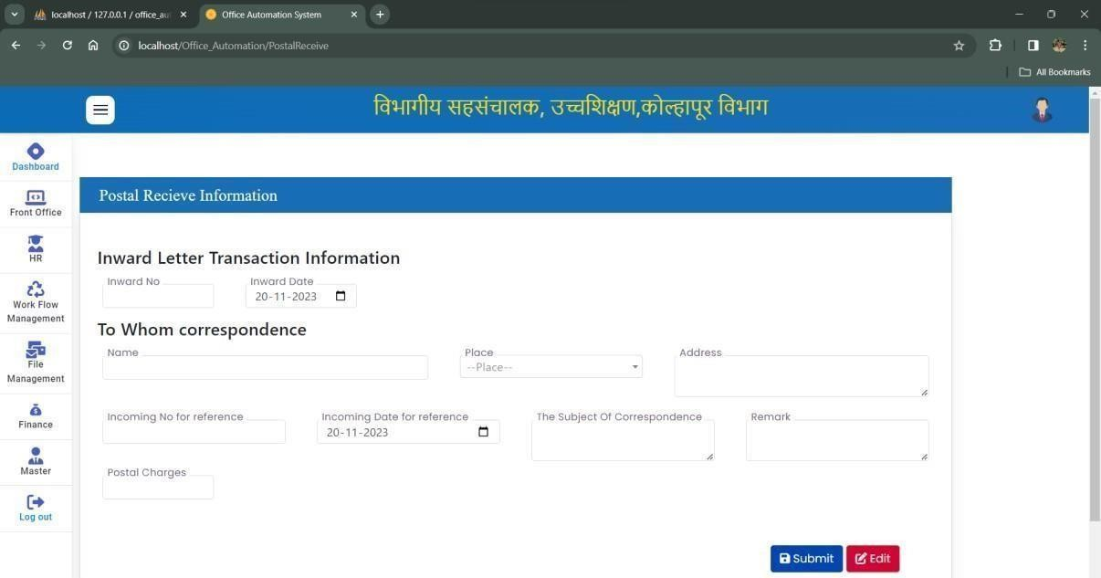

* + 1. **Postal Dispatch Form**

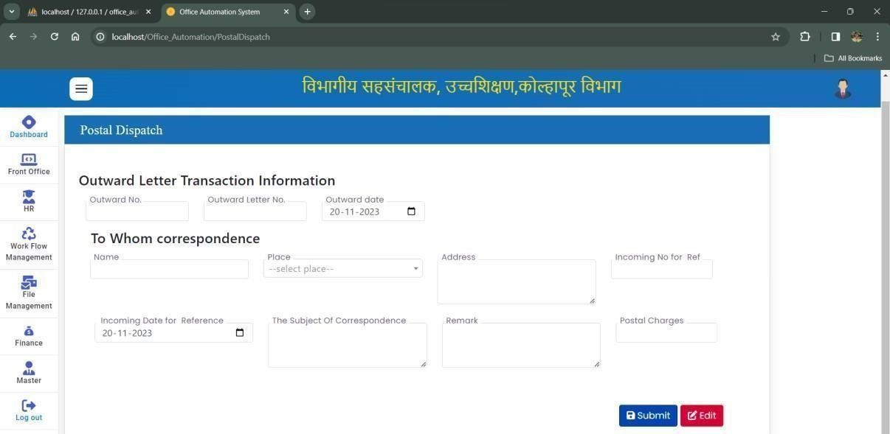

* + 1. **Staff Message Form**

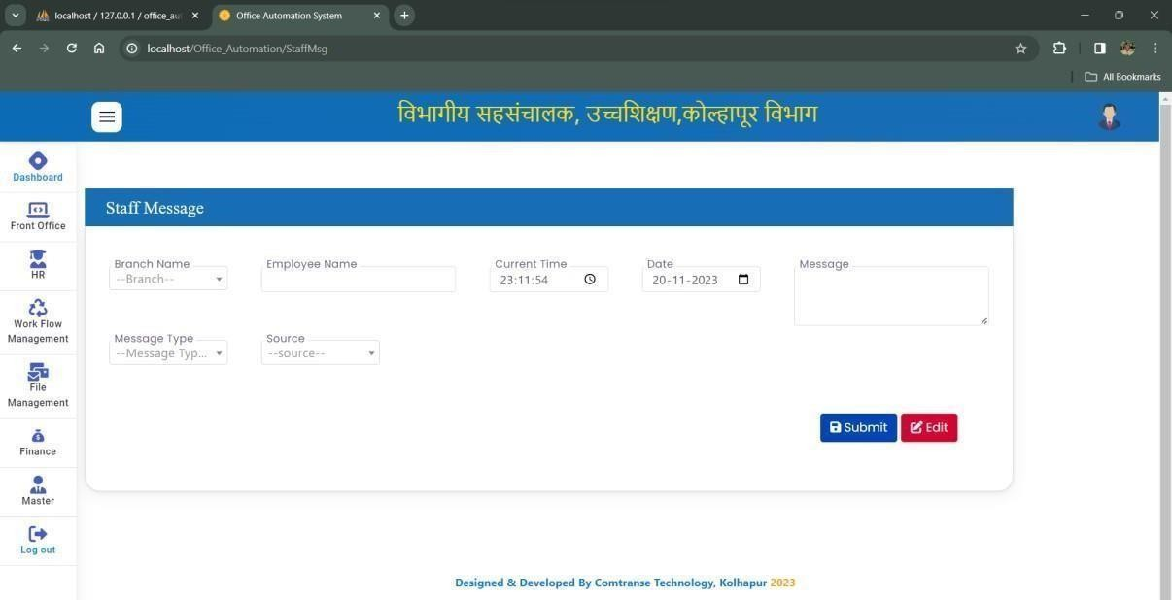

* + 1. **Complaints Form**

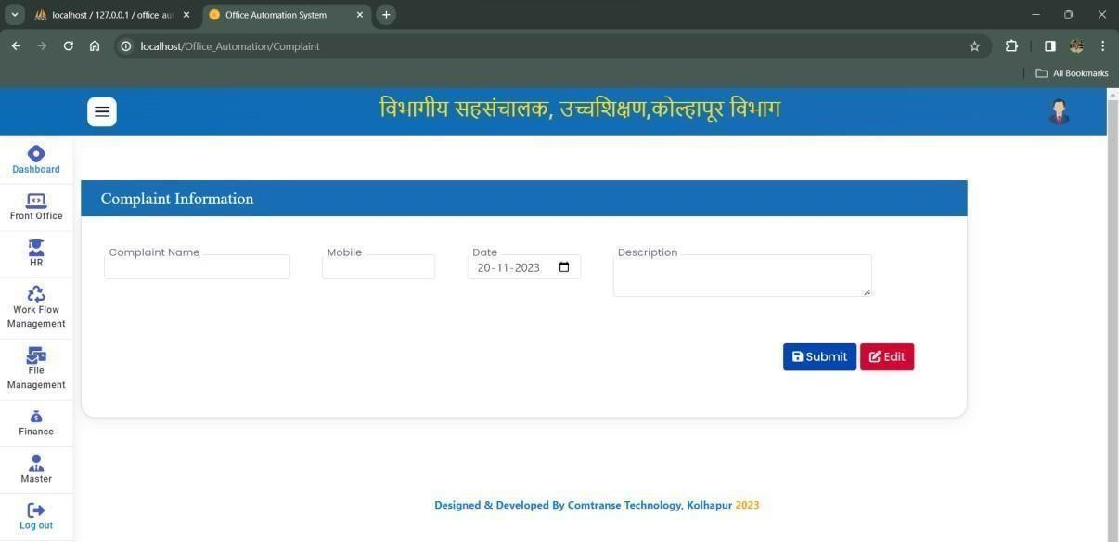

## Output Design

* + 1. **User Login**

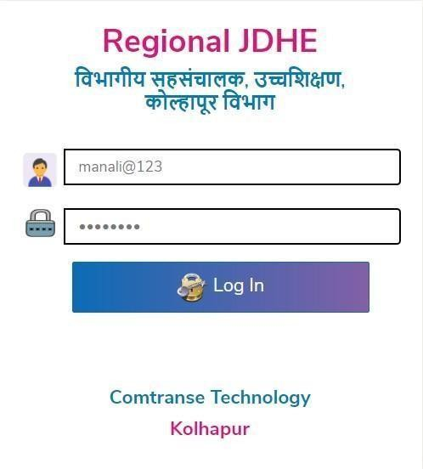

* + 1. **Dashboard**

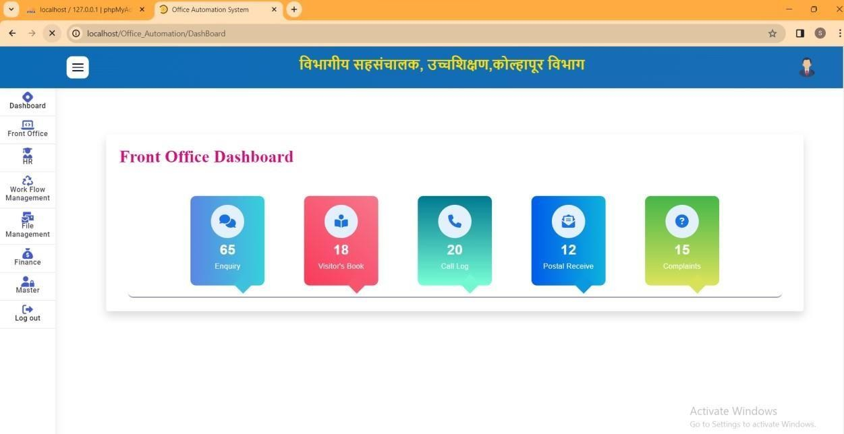

* + 1. **Enquiry Form**

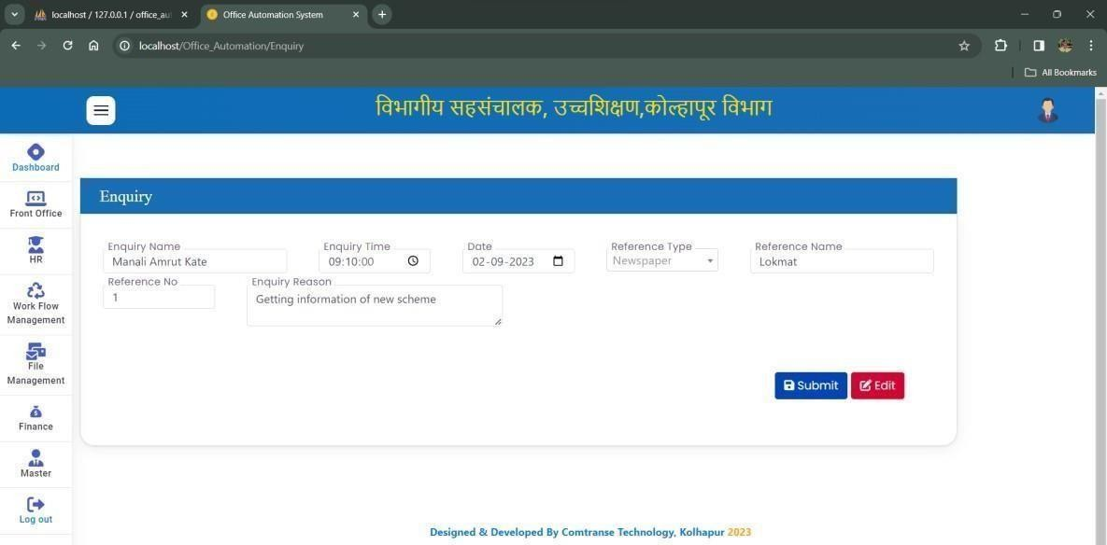

* + 1. **Enquiry Details List**

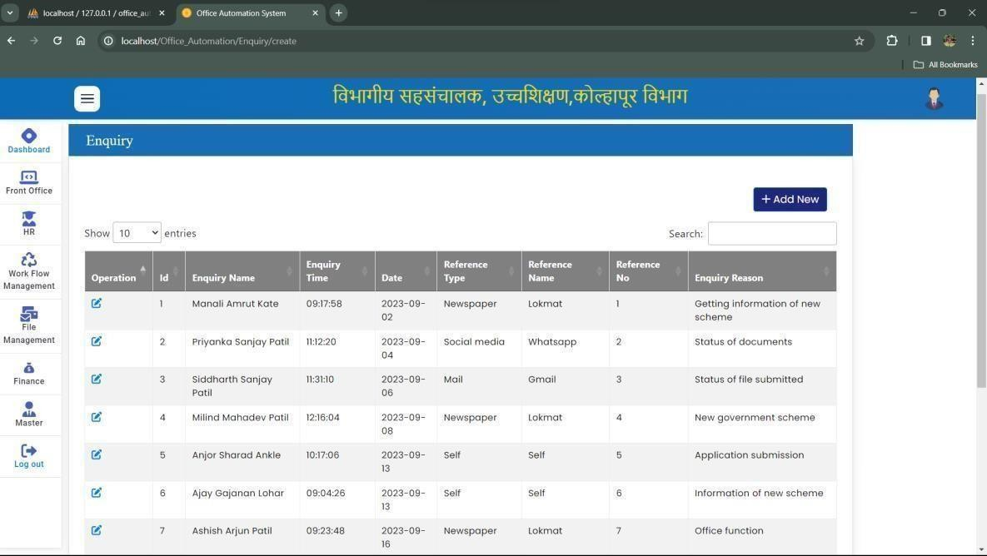

* + 1. **Visitors Book Form**

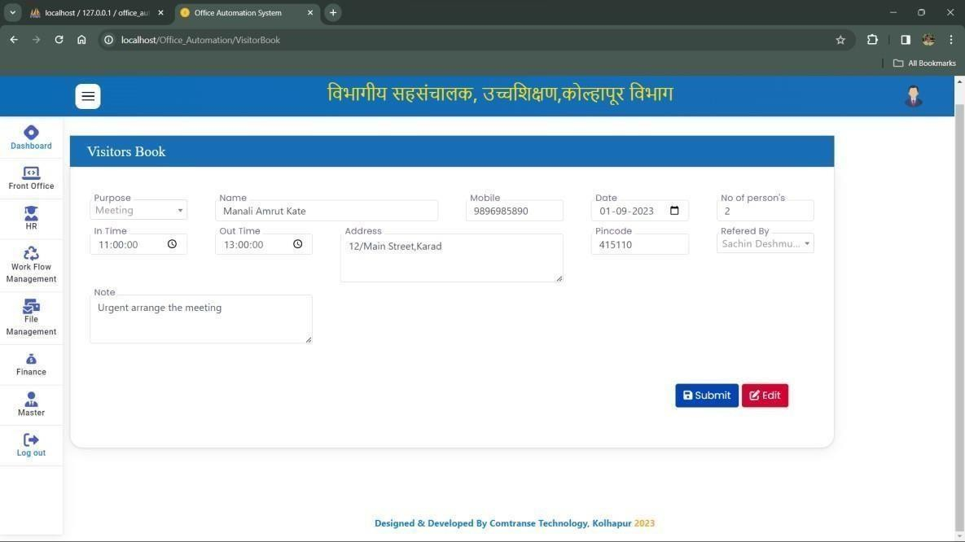

* + 1. **Visitors Book List**

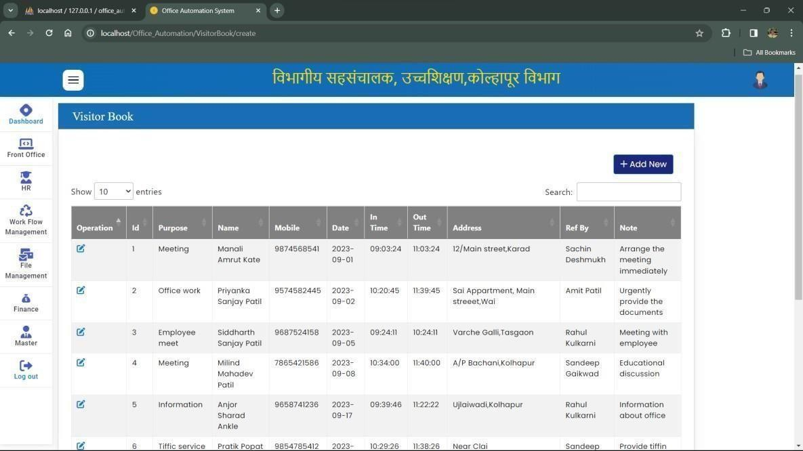

* + 1. **Call log Form**

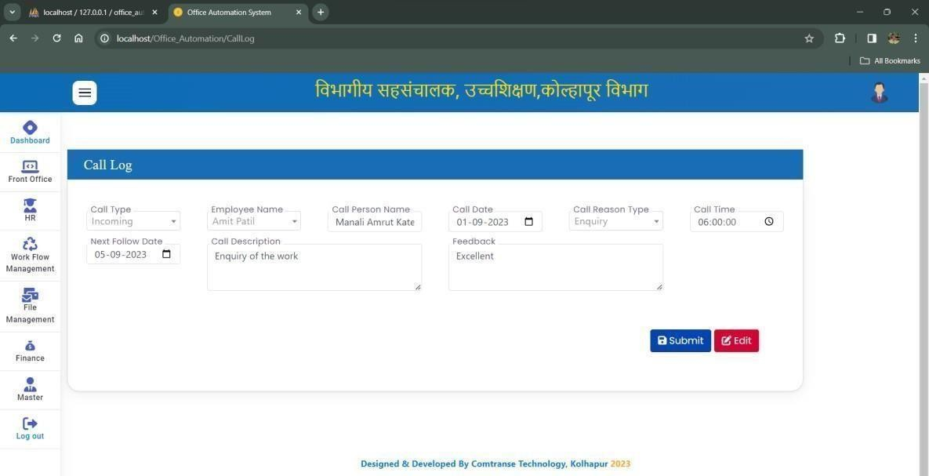

* + 1. **Call Log Details List**

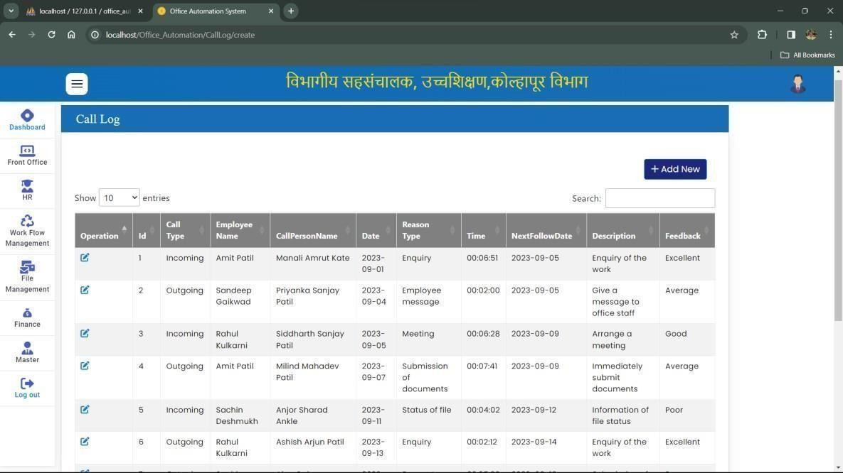

* + 1. **Postal Receive Form**

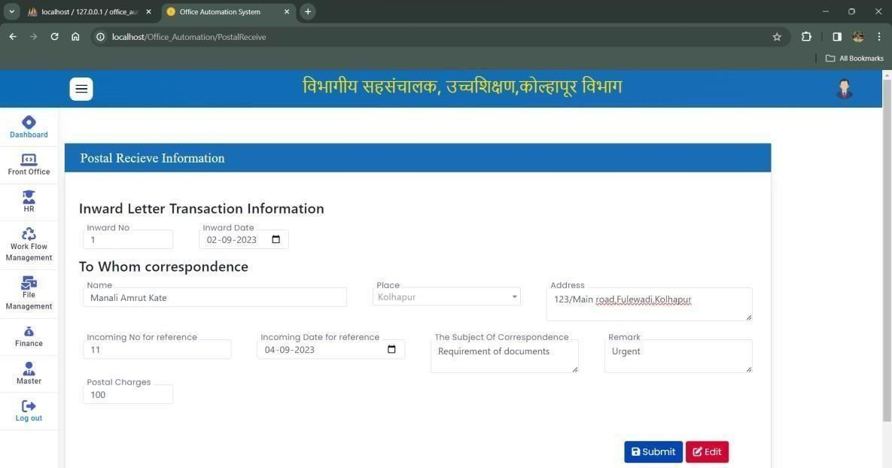

* + 1. **Postal Receive Details List**

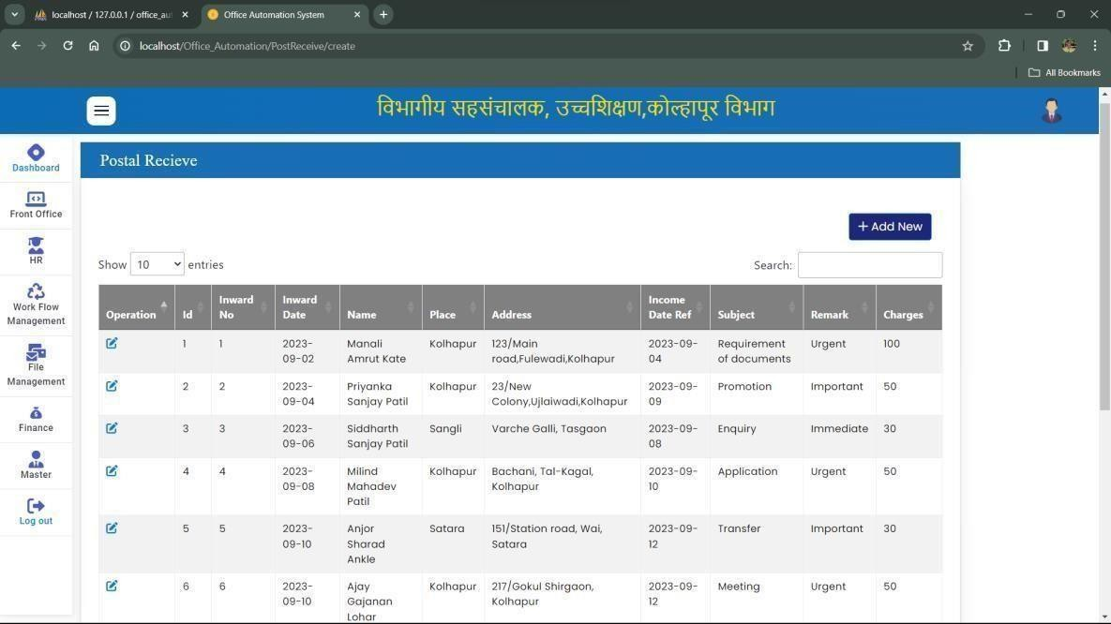

* + 1. **Postal Dispatch Form**

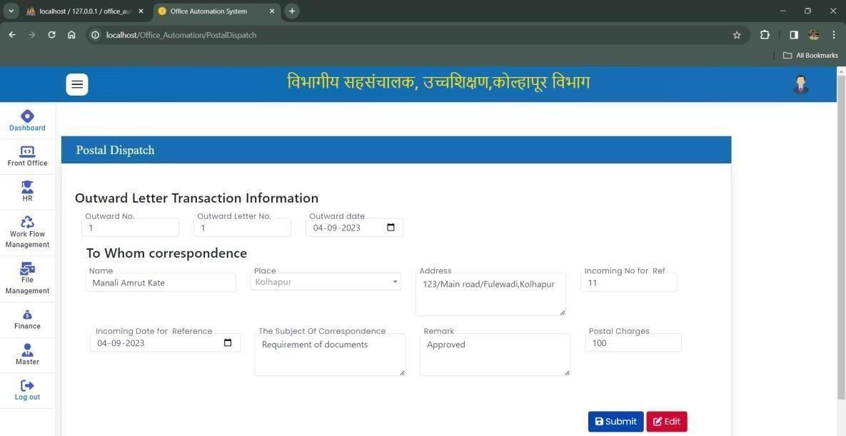

* + 1. **Postal Dispatch Details List**

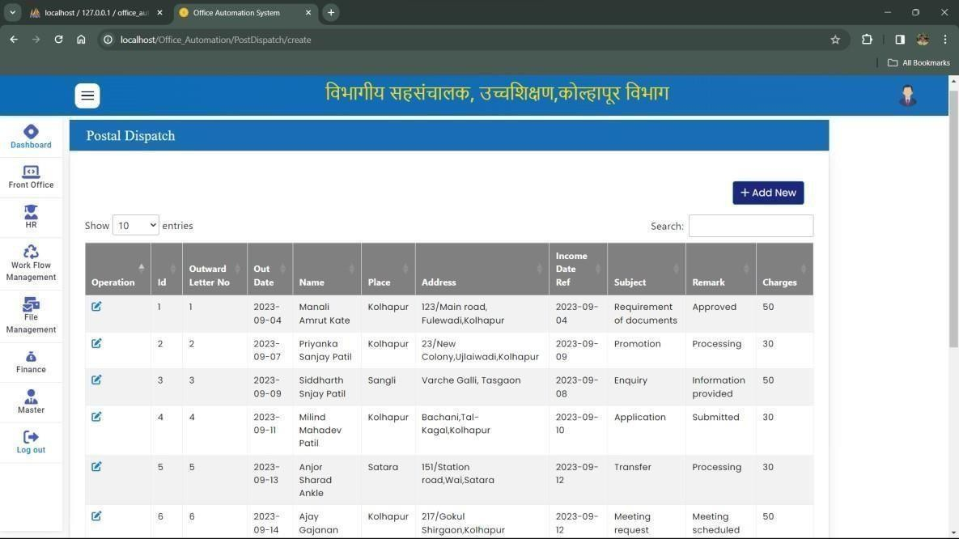

* + 1. **Staff Message Form**

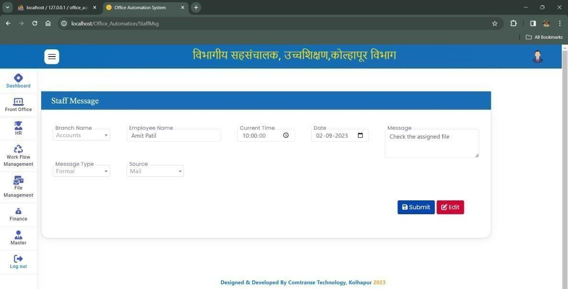

* + 1. **Staff Message Details List**

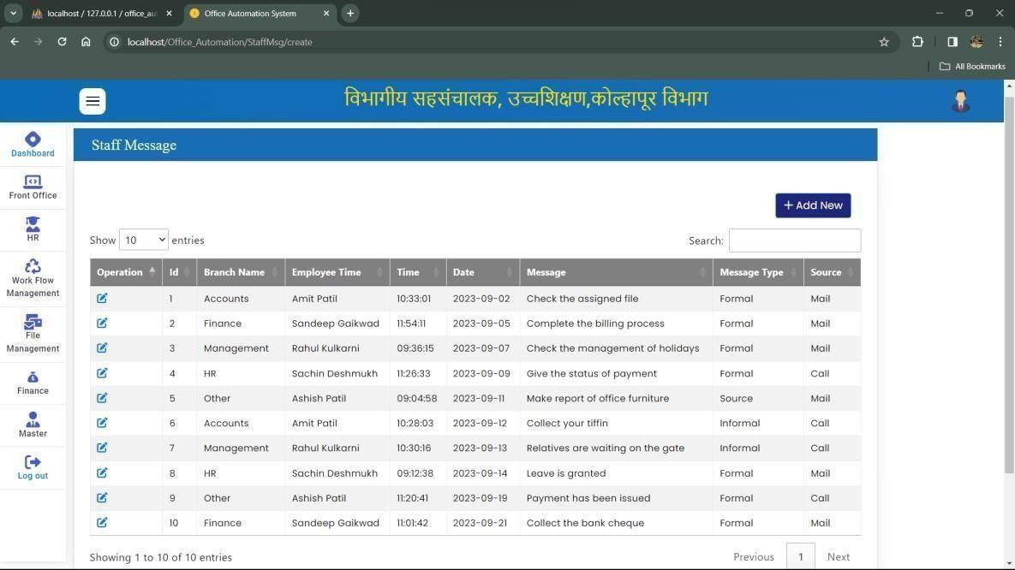

* + 1. **Complaints Form**

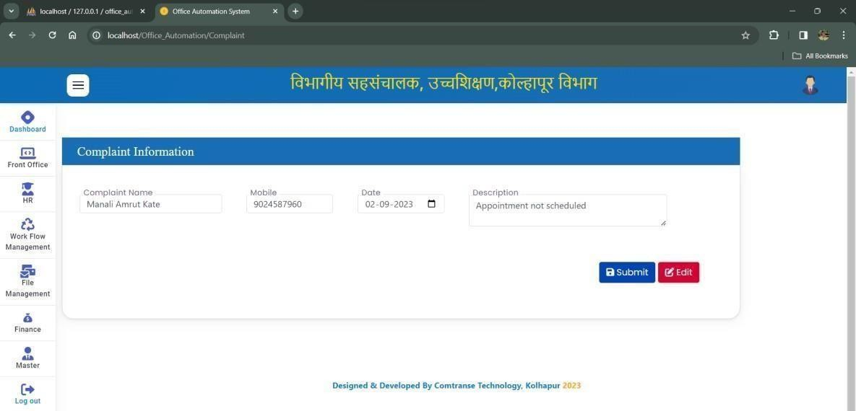

* + 1. **Complaints Details List**

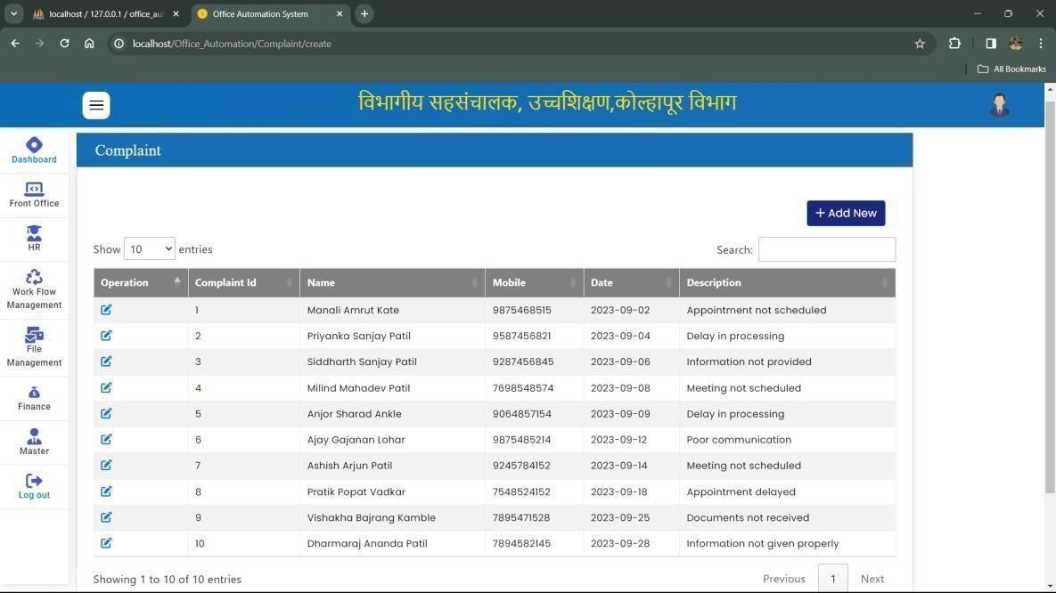

## System Requirement

For this project various technologies are used as follows:

* + 1. **Hardware Requirement**

|  |  |  |
| --- | --- | --- |
|  | Processor: | 11th Gen Intel(R) Core(TM) i3-1115G4 @ 3.00GHz |
|  | Memory: | Minimum 2GB or higher. |
|  | Hard Disk: | 50 GB or higher. |
|  |  | (Minimum 350MB hard disk space for installation) |

* + 1. **Software Requirement**

 Operating system: Windows 7 or above.

 Frontend: HTML, CSS, JavaScript.

 Framework: CodeIgniter Framework.

 Backend: MySQL, PHP.

 Server: XAMPP.

 Editor: Visual Studio Code.

Reports

* 1. **ENQUIRY REPORT: -**

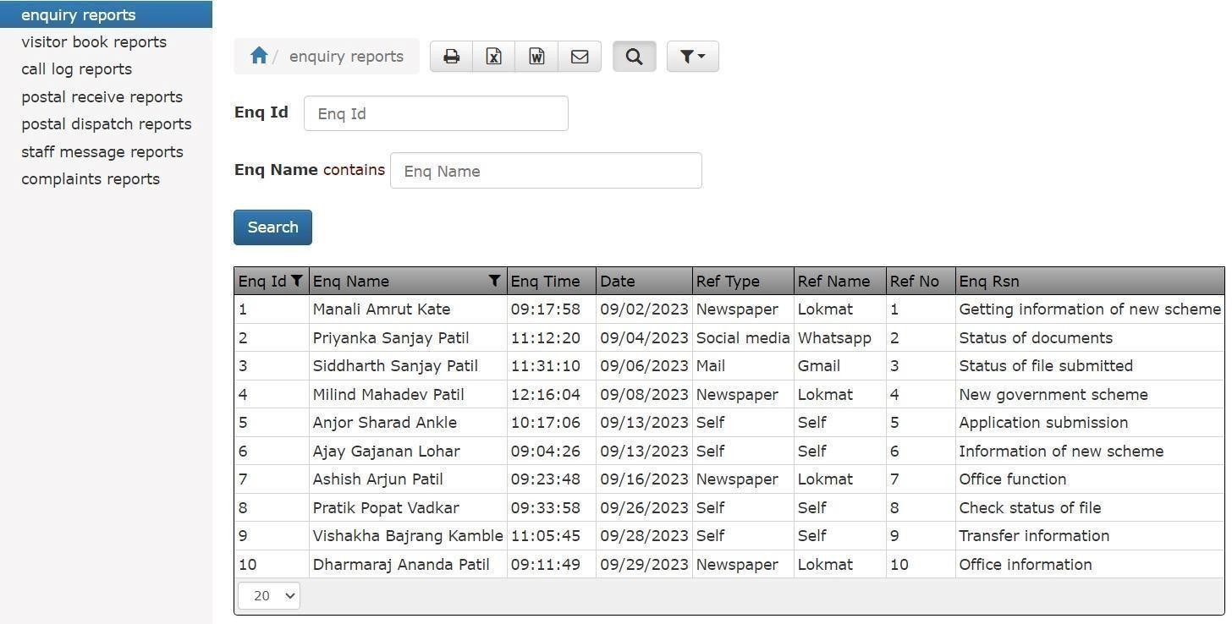

* 1. **VISITOR’S BOOK REPORT: -**

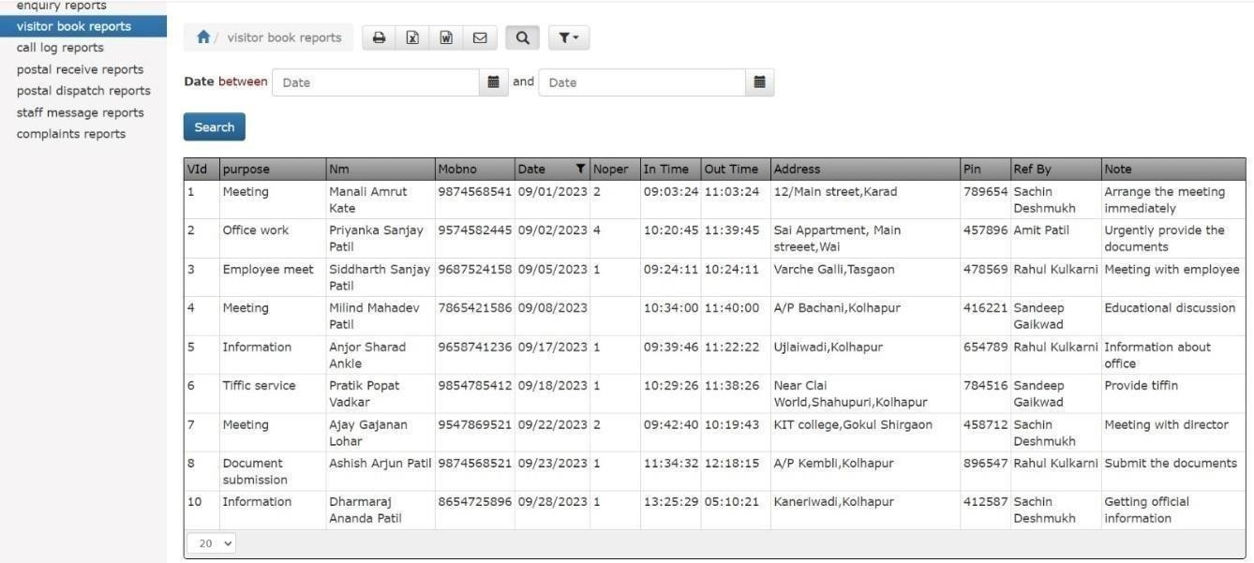

* 1. **CALL LOG REPORT: -**

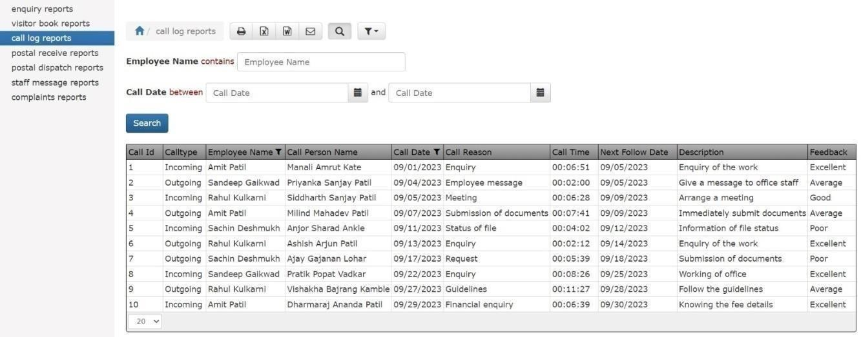

* 1. **POSTAL RECEIVE REPORT: -**

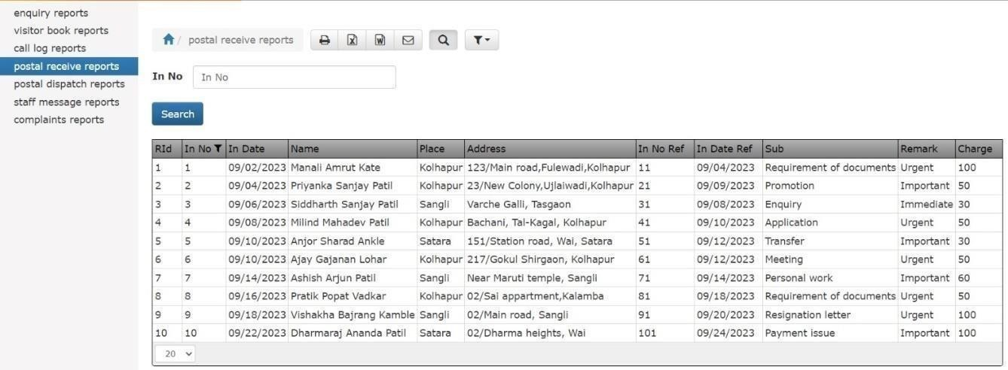

* 1. **POSTAL DISPATCH REPORT: -**

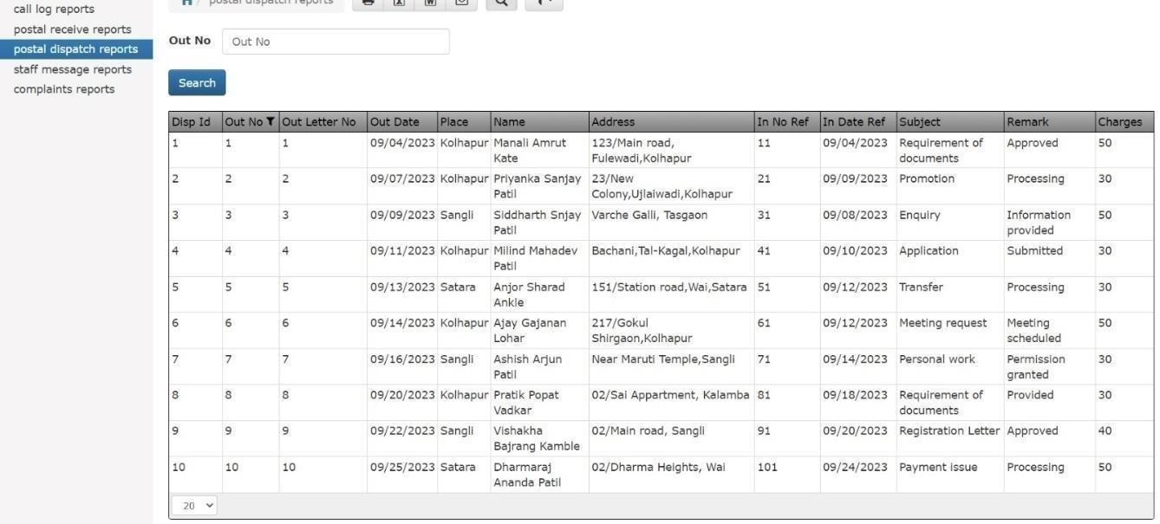

* 1. **STAFF MESSAGE REPORT: -**

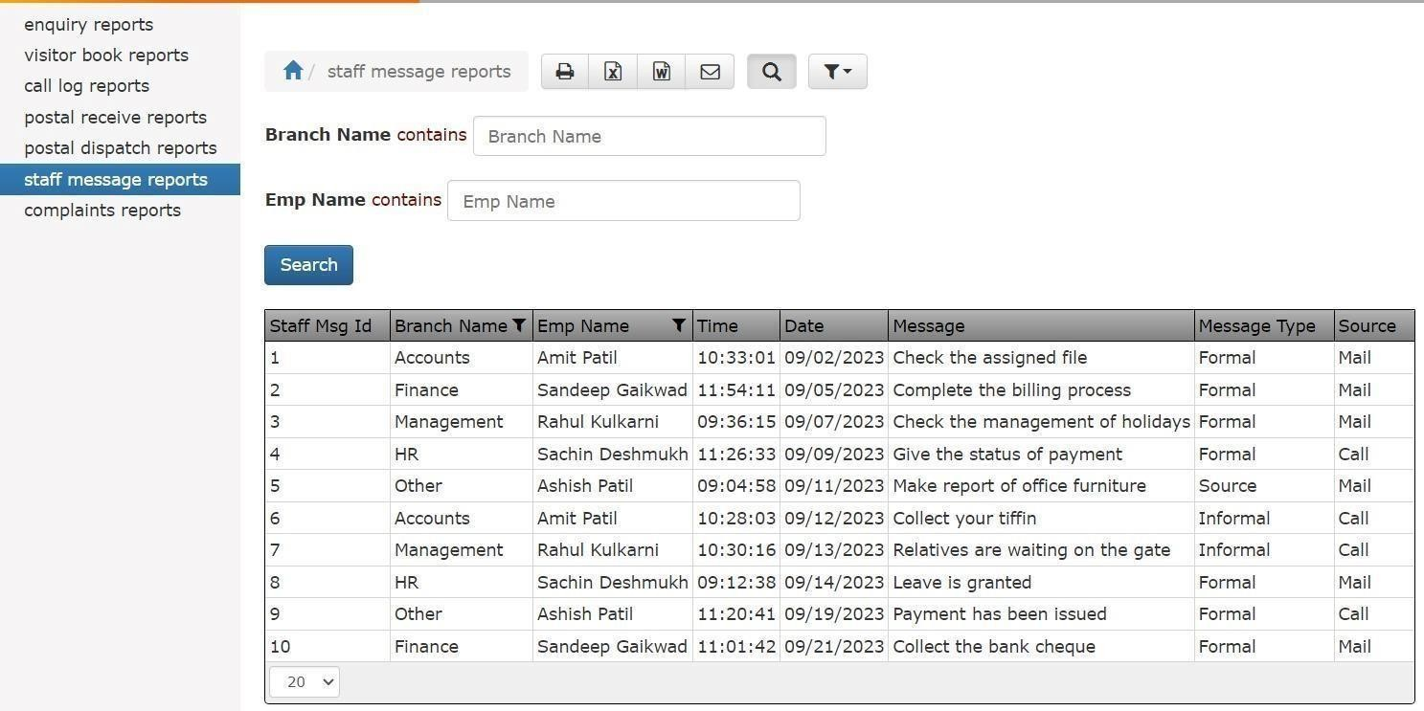

* 1. **COMPLAINT REPORT: -**

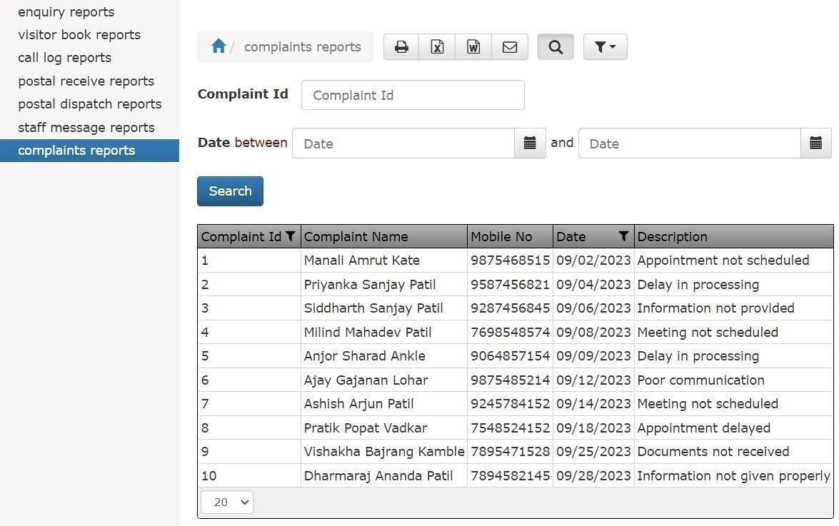

* 1. **Conclusion: -**

 Being a computerized system, it is accurate, time saving and beneficial with paperless documents. It minimizes error at greater extent. It gives you information about working of the various departments.

 The tremendous advantage offered by the Office Automation System is that user can create account and admin can assign the role to users. The admin has control over the system and on every user of that system.

 This system proves to be very beneficial to the users as it minimizes the errors and the overall time required to complete a task.

 Adoption of this system boosts the productivity of the employees and gets the actual work done in proper and accurate manner.

* 1. **Limitations:**

 This system is not fully automated.

 Man power is required for handling this system.

 Basic computer knowledge is compulsory for handling system

* 1. **Suggestions:**

 Log out when system is not in use.

 Keep outside people away it may temper your data.

 Insert proper records in system.

 Records should not be blank while inserting data into system.

 Database maintenance is required.

## References

During the development of our system, we have taken the reference from various books and journals, which we would like to mention in this section.

### Reference books:

 DT Editorial Services - HTML 5 Black Book: Dreamtech Press

 Jesus Caspagnetto - Professional PHP Programming: Etal. Wrox Publication.

 Kogent Learning Solutions - Web Technologies Black Book: Dreamtech Press

 Ralph Moseley and M. T. Savaliya - Developing Web Applications: Wiley- India.

 Robin Nixon - Learning PHP, MySQL, JavaScript, CSS and HTML 5: O‟Reilly Publication

 W. Jason Gilmore - Beginning PHP and MySQL: From Novice to Professional, Fourth Edition

### Websites:

* + - * [http://www.Tutorialspoint.com/](http://www.tutorialspoint.com/)
      * [www.w3school.com](http://www.w3school.com/)
      * <https://getbootstrap.com/>
      * <https://codeigniter.com/>